LAB TEST : 02
Name: M.Sathwik.
Roll No: 2403A51048
Batch: 02

Subgroup E

P.1 — [S01P1] Validate and Mask Credit Card Numbers

Scenario (E-commerce):
Context:
In an e-commerce platform, customer credit card numbers are stored temporarily before being passed to a payment gateway. For security, only the last 4 digits should be visible to support staff during troubleshooting.

Your Task:
- Write a function that:
  - Validates if a given string is a 16-digit numeric credit card number.
  - Returns a masked version where only the last 4 digits are visible, and the rest are replaced with *.

Data & Edge Cases:
- Input may contain non-numeric characters → reject as invalid.
- Input shorter or longer than 16 digits → reject as invalid.
- Return "Invalid Card" in invalid cases.

AI Assistance Expectation:
- Use AI to scaffold:
  - Regex check for 16-digit numeric input.
  - String slicing and masking logic.
- Generate tests for valid/invalid card numbers.

Constraints & Notes:
- Do not use external libraries; stick to built-in Python.
- Ensure the function is reusable for lists of card numbers.

Sample Input:
card = "1234567812345678"

Sample Output:
************5678

Acceptance Criteria:
- Returns masked string correctly for valid 16-digit inputs.
- Returns "Invalid Card" for invalid inputs.
- Handles multiple test cases in a list of cards.

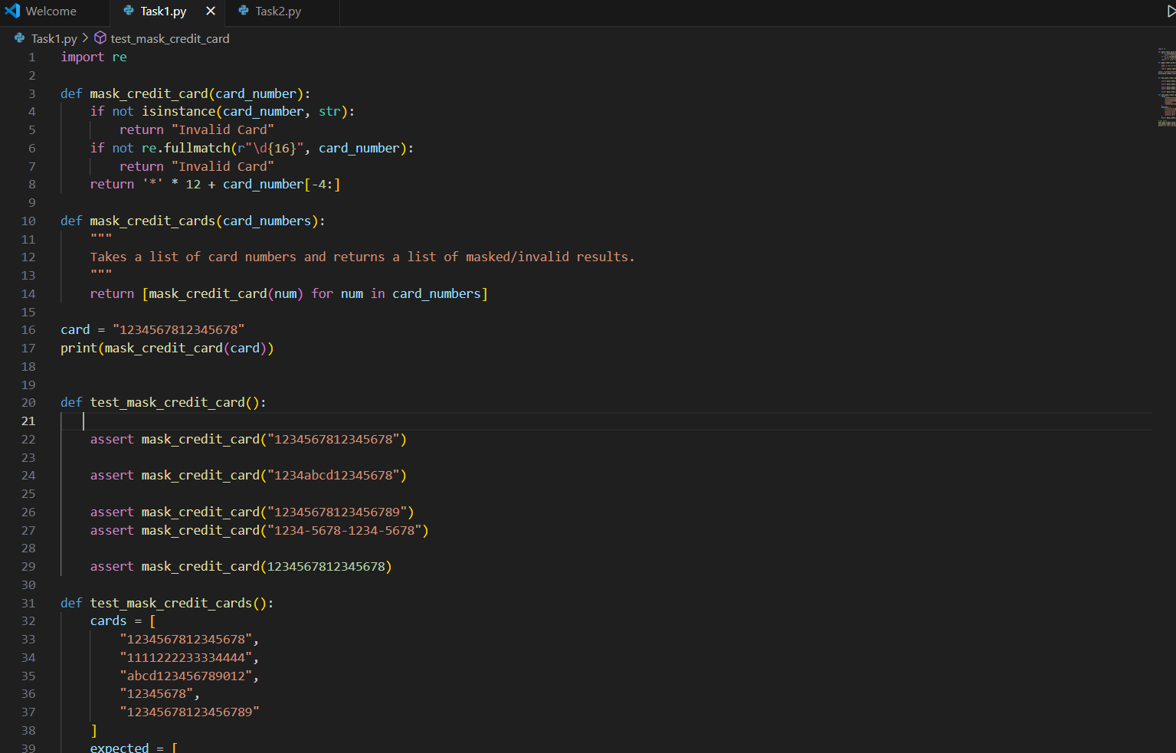
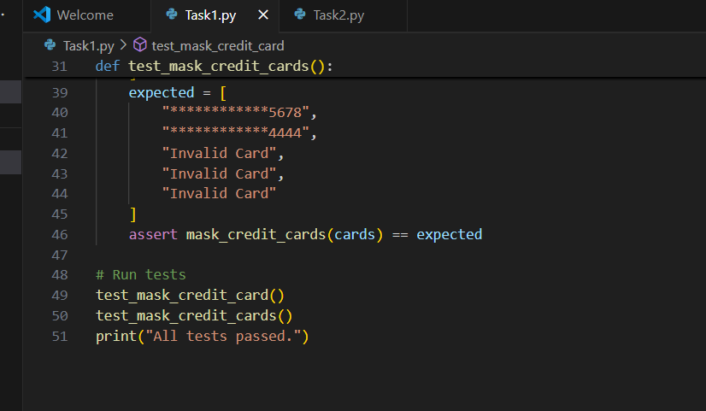

OUTPUT:
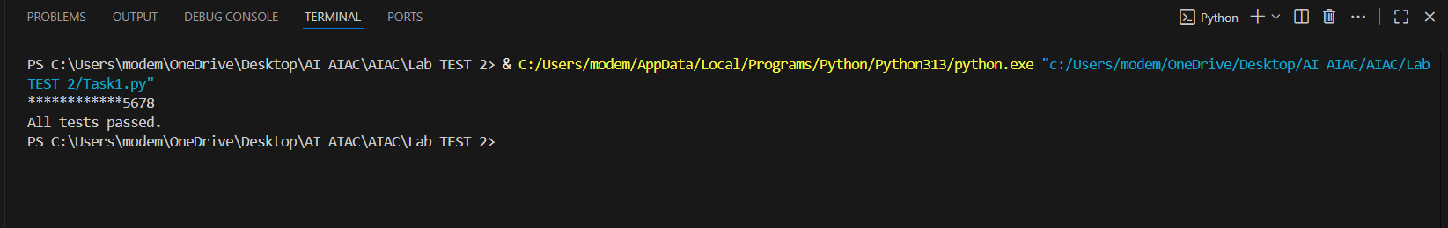

E.2 — [S13E2] Refactor nested loops to dict aggregation
Scenario (agritech):
Context:
A legacy agritech script uses verbose loops to aggregate key-value tuples.

Your Task:
Refactor to a pythonic aggregation using dict.get or collections.defaultdict with type hints.

Data & Edge Cases:
Input example: [('a',1),('b',2),('a',3)] -> {'a':4,'b':2}.

AI Assistance Expectation:
Ask AI for refactor suggestions, then apply and ensure behavior parity via tests.

Constraints & Notes:
Type hints for function signatures required.
Sample Input
data=[('a',1),('b',2),('a',3)]
Sample Output
{'a':4,'b':2}
Acceptance Criteria: Behavior unchanged; improved readability

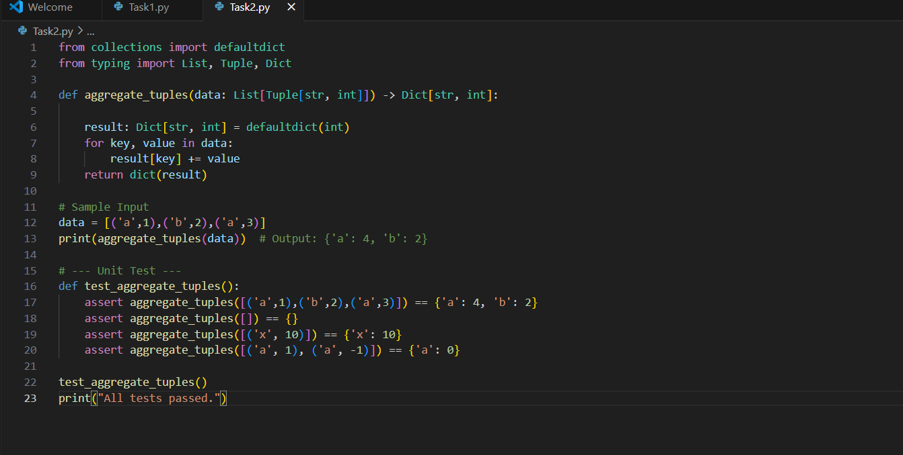

OUTPUT:
